**Budgie: A Budget Management Mobile Application for Plaksha students**

A Human-Computer Interaction Project Report by:

**Team 3**

Kishlay Kumar

Pratyay Prakhar

Vivek Kumar

Submitted to

Dr Sudheendra Hangal

CEO, Amuse Labs

Contents

Acknowledgement 3

Introduction to the Problem 3

Background/ Related Work 4

Understanding Users 4

Prototyping 4

Overview of the app 6

7

User Testing 7

Methodology 7

User reactions and learnings 8

User group 1 – UG students 8

User Group 2 – TLP Students 8

User Group 3 – Faculty, staff, and visitors 9

Conclusion 10

Team 10

Gallery 11

Resources 12

# Acknowledgement

Professor Hangal played an instrumental role throughout the project. We are extremely thankful to them for volunteering their time to help us out with the ideas and guide us on how to make the application better. The learnings from the course helped us critically evaluate our own decisions as we went through different phases of the project. The effort they put into making sure every team’s concerns were addressed is impressive.

We express our sincerest gratitude to our teaching assistant, Akbar Surani. Their introduction to Balsamiq session was a great launchpad for getting started with our respective projects. They spent an immense amount of time critically evaluating the apps and gave great insights into how user testing and prototyping must be done.

The final version of the mobile application prototype which was presented would not have been possible without the input and feedback of each of the users who volunteered their time to evaluate our prototype. We learnt a great deal about where we went wrong from each of them.

# Introduction to the Problem

The inspiration for the application stems from the everyday financial struggles of the students studying across different universities in the country. Because of the paucity of on-campus jobs, a significant majority of the students at Plaksha University solely depend on their parents for their monthly pocket money. This dependence calls for personal financial literacy which can be enabled by giving the students a platform to manage their budget better.

There are certain key challenges that the students at Plaksha University face concerning their finance:

1. Spending money as soon as they get their monthly budget.
2. Not knowing how to use their budget responsibly.
3. Running after people to get the amount they owe back.
4. Losing track of the expenses occurred.
5. Lack of motivation to stay firm on the budget goals.

These key challenges were identified through conversations with the students of Plaksha University who voiced the aforementioned concerns.

# Background/ Related Work

There are a lot of personal finance applications available digitally. We evaluated 4 such applications and our analysis suggested that they do not offer solutions for all key student budget problems. A lot of emphasis was placed on incorporating features related to investing in stocks rather than getting the fundamentals of personal finance right.

There does not exist an application which solves all the identified problems in one place. There are different applications for splitting the expense and different ones for tracking the expense, but no singular application integrates all the features.

The apps also did not offer users the freedom to personalise their overall experience to keep them engaged. Some of these applications force the user to add their bank accounts compulsorily before onboarding which undermines the need for a user to manage their cash reserves only.

# Understanding Users

The target audience for our application is Plaksha University students. The scope can be extended to include university students across the country if the idea seems viable.

We spent some time doing user research and realised that most of the students here do not use any budget management application currently. Another insight gathered was that the students do not have a habit of tracking their expenses and mostly rely on their memory to recollect the expenses incurred over a given time.

A participant talked about their experience of going on an excursion with their peers and struggling to get the amount they paid for food for everyone back from them. Another participant complained about their food indulgence and how they end up spending most of their budget on food which eventually leads to regret.

A participant said that they maintain a diary in which they try to write down their expenses and considered it a messy affair. The consensus was that the participants were not aware of any digital solution to their budget-related needs.

# Prototyping

Since the goal of the project was to maximise learning to work ratio, we started with a low fidelity prototype-paper prototype. With the idea of the interaction of the users with the application in mind and the user flows defined in our scope, the decision about what would go into the screens was finalised and drawn on paper. The focus was on keeping the features minimalistic and relevant. Thus, functional features like having an analytics dashboard were not considered in this version.

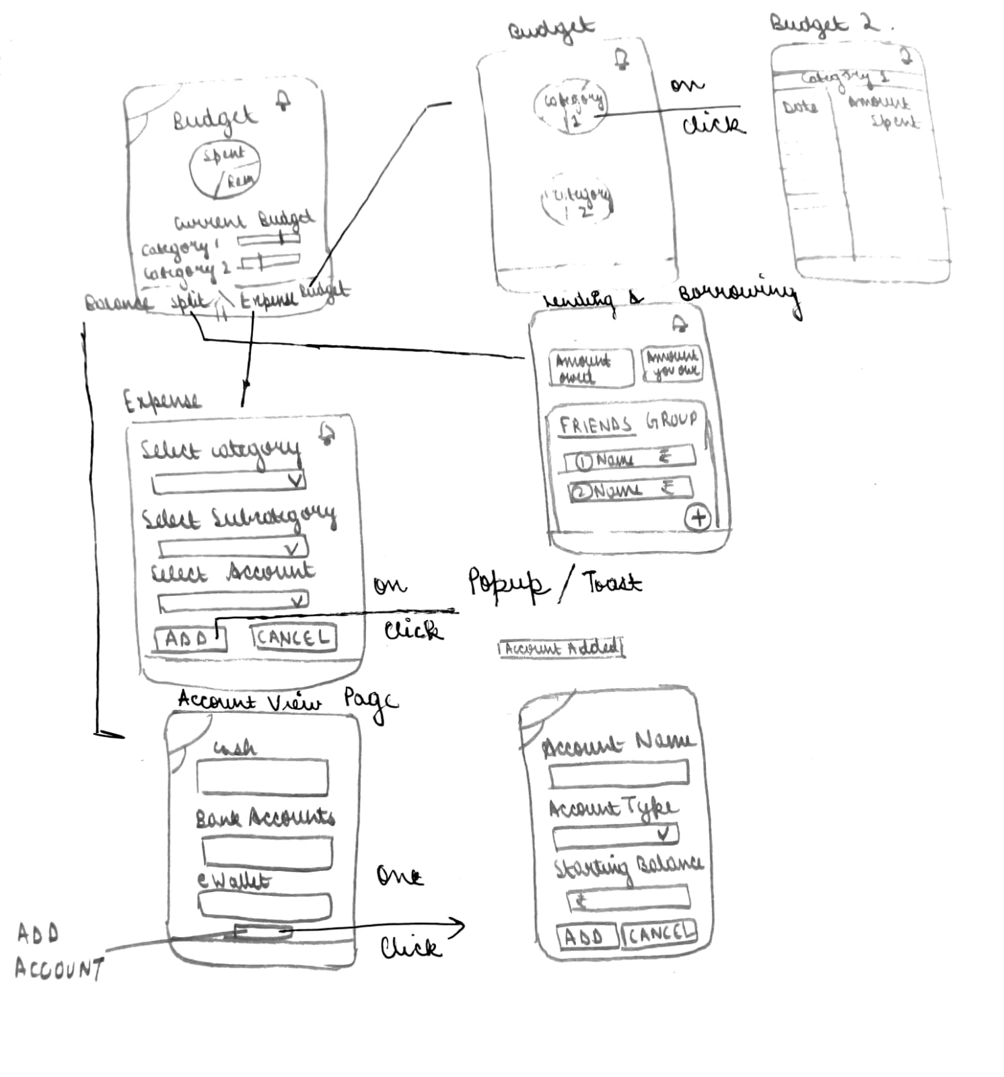

Fig 1: Paper Prototype

The approach followed for prototyping was iterative. The improvements suggested by the users were first drawn on the paper prototype and then modified in the Figma design. Paper prototyping was the faster and easier way to help realize our vision and design user flows and layouts without being restricted by the limitations of digital prototyping tools.

# Overview of the app

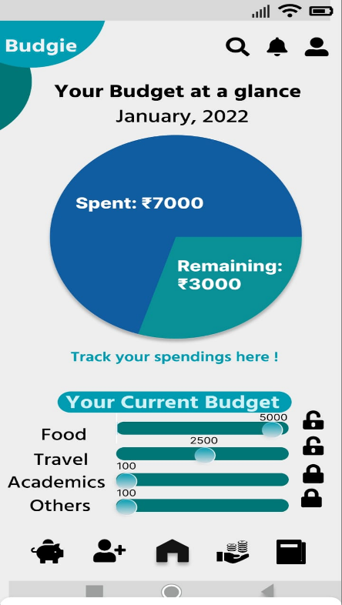The features of the app are as follows:

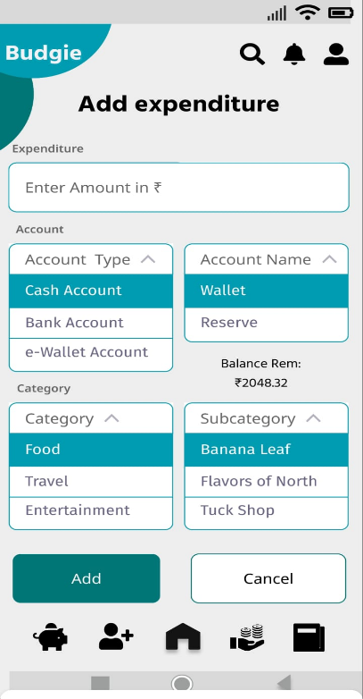

Home Screen Add Expense Screen

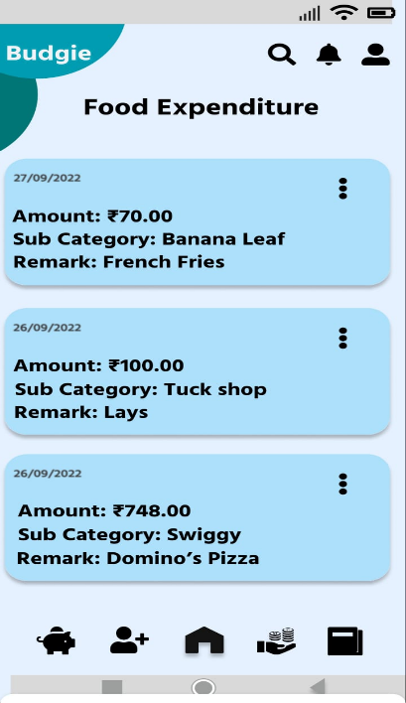

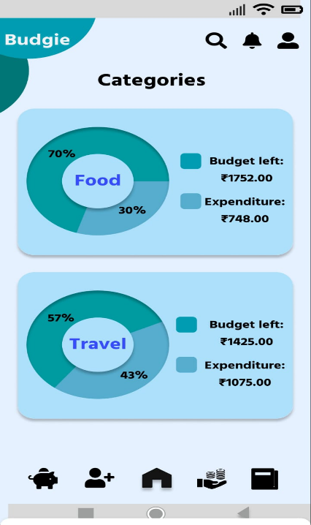

Categories Screen Expenditure Details Screen

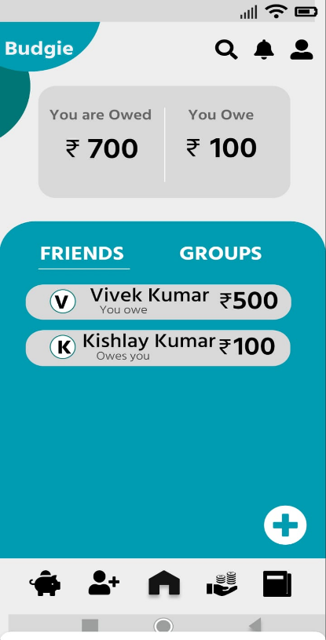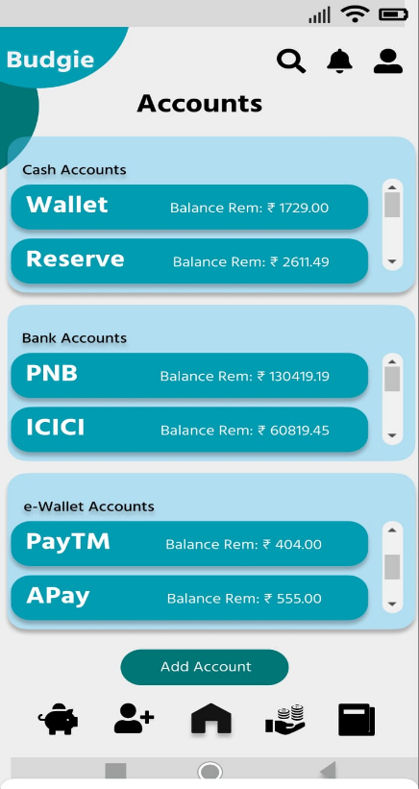

Accounts Screen Lending and Borrowing Screen

# User Testing

## Methodology

For the purpose of user testing, we divided the users into different segments:

* Undergraduate students (Long term users)
* TLP students (Short term users)
* Faculty, staff, and visitors (Casual users)

The idea behind such a categorisation was to expose the interface to users with different perspectives. Since, the application is personalised to cater to needs of the Plaksha community, it is imperative to get different opinions to develop an app that can be used by all. The steps followed for user testing were as follows:

1. Give the user a brief idea about the user test session, make them comfortable, and talk to them about the need for a personal budget management system.
2. Give a general overview of the app.
3. Ask the user to launch the app and assess the home screen features.
4. Let the users explore the different pages on the app using tab icons.
5. Ask the users to open each page and perform specified tasks.
6. Encourage users to put their thoughts into words in each step.
7. Note down whenever a user faces any inconvenience when performing a any task.
8. Ask the user about their general experience with regards to ease of use and aesthetics.

## User reactions and learnings

### User group 1 – UG students

A group of users wanted the app to offer a personalised experience through the use of subcategories such as ‘Banana leaf’ and ‘The flavours of the North’ which are specific to our university. We learnt to empathise with the choices of the users through this.

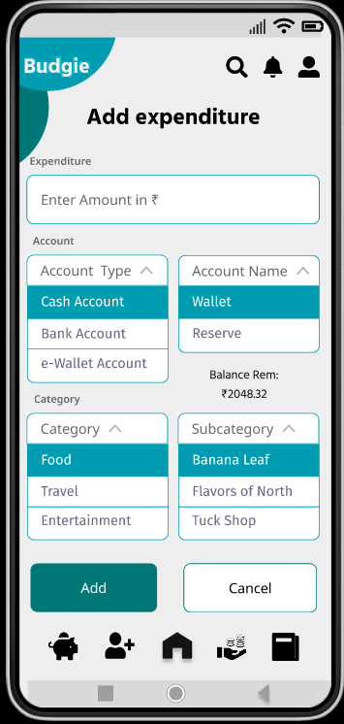

A first-time user would want to seamlessly interact with the application without the hassle of clicking on the icons to navigation to different screens. One of the user groups suggested allowing users to swipe through different screens quickly.

### User Group 2 – TLP Students

A user with a good understanding of HCI helped us identify a major flaw with the design. The slider for setting the budget leaves space for the users to make mistakes easily. We added a lock element for error prevention and also give users the ability to enter the amount, thus getting rid of the accessibility challenges of the slider element.

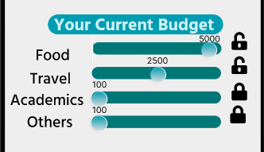

They also suggested a futuristic solution to extract data from their social media posts to make it easier for them to identify their expenses and the people who owe them money.

A change in a design icon to use red colour for critical updates through notifications was a small change but one which aligned well with the mental model of the user.

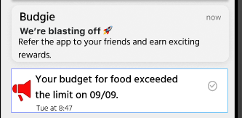

One of our users struggled with navigating to the granular view for the budget under a category. To fix this, we added cards to enable users to understand that they need to click on it.

They also wanted to have the option to update expenses and fix errors which incidentally happens to link to the recovery from error heuristic.

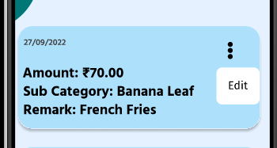

### User Group 3 – Faculty, staff, and visitors

One of our users who happened to be a member of the program team was confused by the ‘Books’ category. They identified that educational spending in today’s day and age can be in multiple forms like e-Books, MOOC courses, cloud service subscriptions, etc. Hence, they suggested using a more encompassing category name like ‘Academics’.

They also wanted to have the view of the balance in her accounts while adding expense and thus, we added a design element to remove the burden of going to the account screen thus leveraging recognition rather than recall.

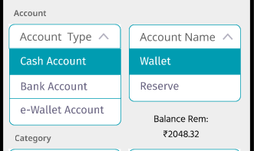

# Conclusion

The project introduced us to a very important facet of product development-designing and user testing. The opportunity to let our vision come into life and get feedback and guidance along the way was full of profound learnings which will be extremely helpful in building human-centric products.

User testing helped us understand the importance of empathising with the needs of the users. The realisation of issues that were overlooked has expanded our critical thinking process. Paper prototyping was a fun way to brainstorm ideas and leverage our creative abilities. Digital prototyping gave us the hands-on experience of how product design prototyping is done in the industry today.

The biggest key takeaway from this project is to always think about the users at every step of the process. This prevents us from getting distracted by the nitty gritty and technicality of the features and focuses on what is needed to make the product a worthy one for the users.

# Team

Shared

User testing.

Kishlay Kumar

Design and digital prototyping.

Pratyay Prakhar

Presentation and report.

Vivek Kumar

Paper prototyping and presentation.

# Gallery

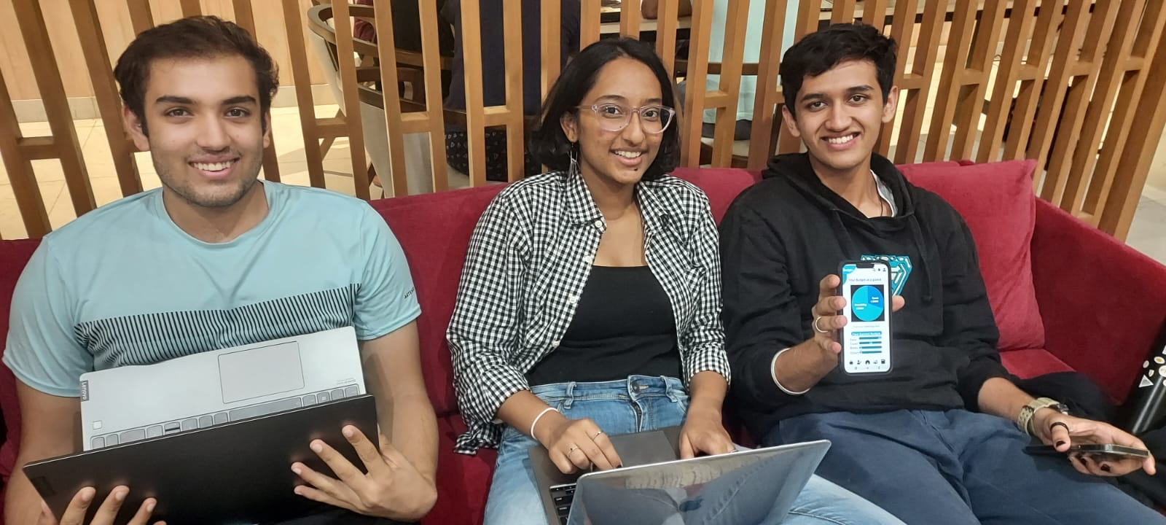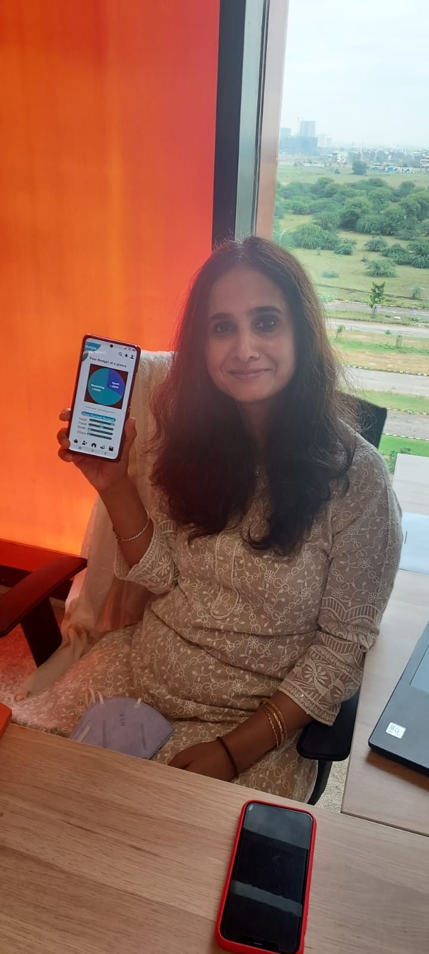

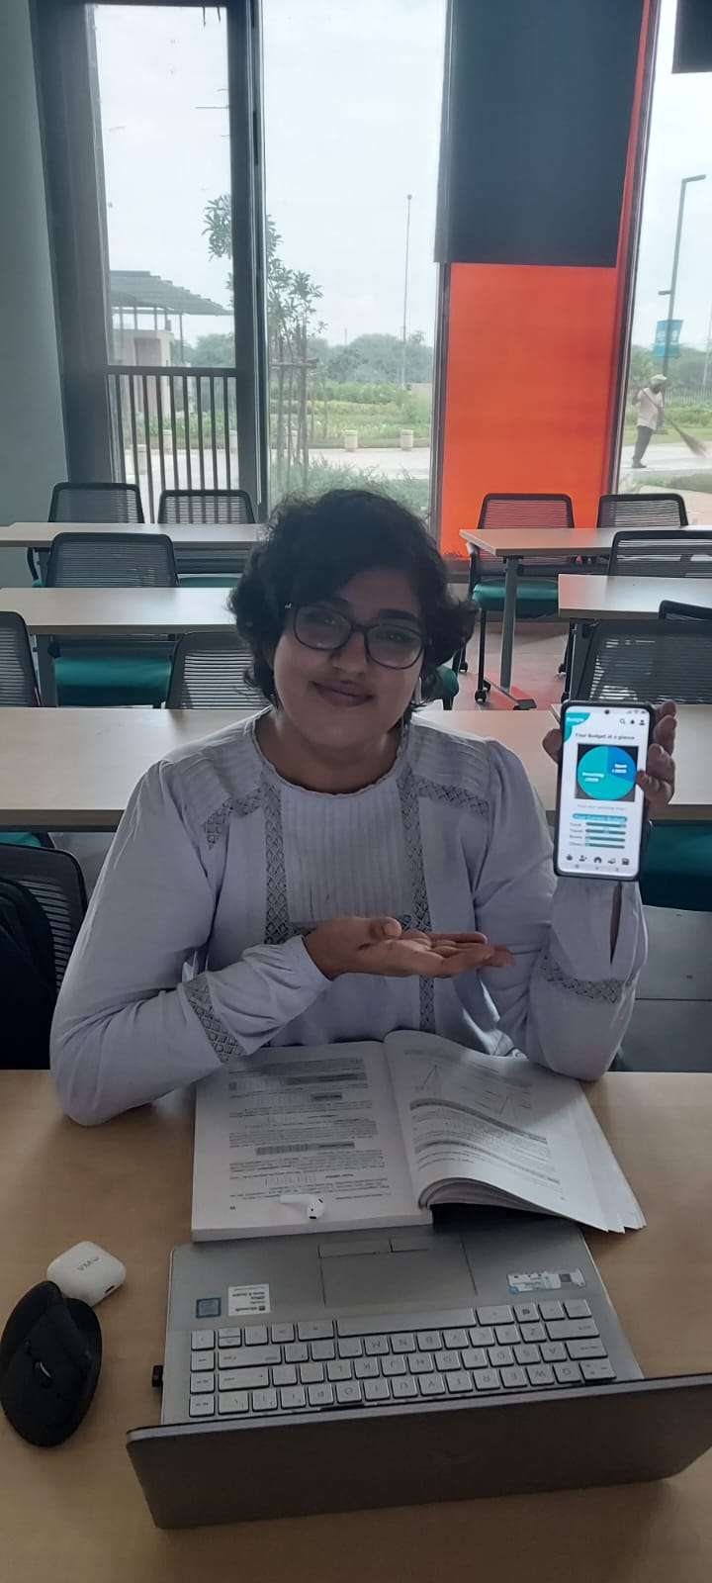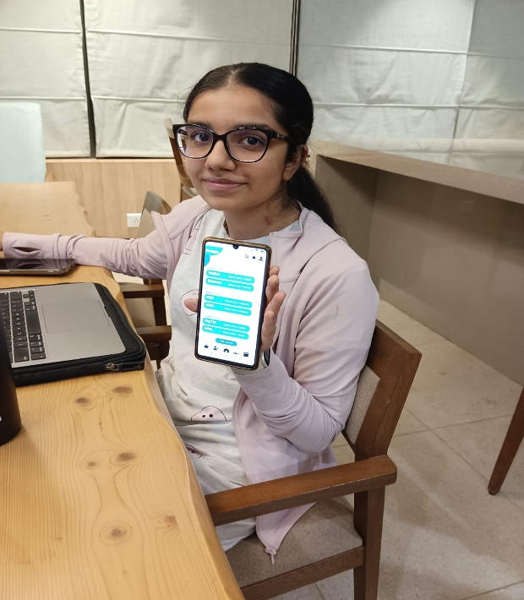

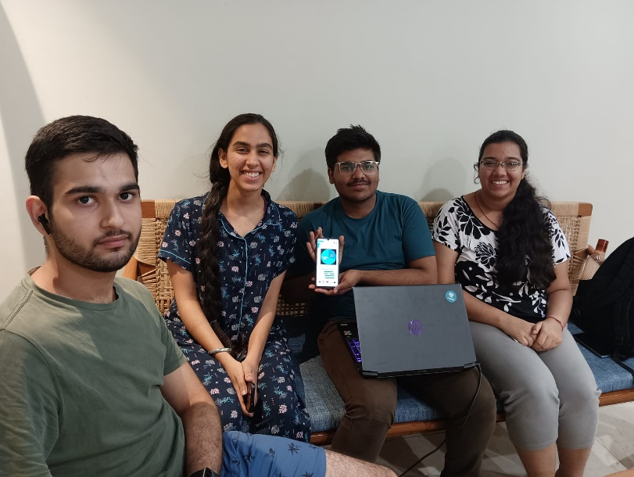

# Resources

Figma project link: <https://www.figma.com/file/l9NX4FcSntGNyJw0GlEOcW/Plaksha-Budget-Management-Appplication?node-id=0%3A1>